**Testing the Website https://www.ffl123.com/**

Suggestion: Change the layout of the main Menu **Steps to reproduce:**

- Open the **https://www.ffl123.com/**

- Click on the Menu icon on the top right

- Menu should be more accessible

- Arrange the items from the menu to be visible on the top of the Page.

Screenshot:

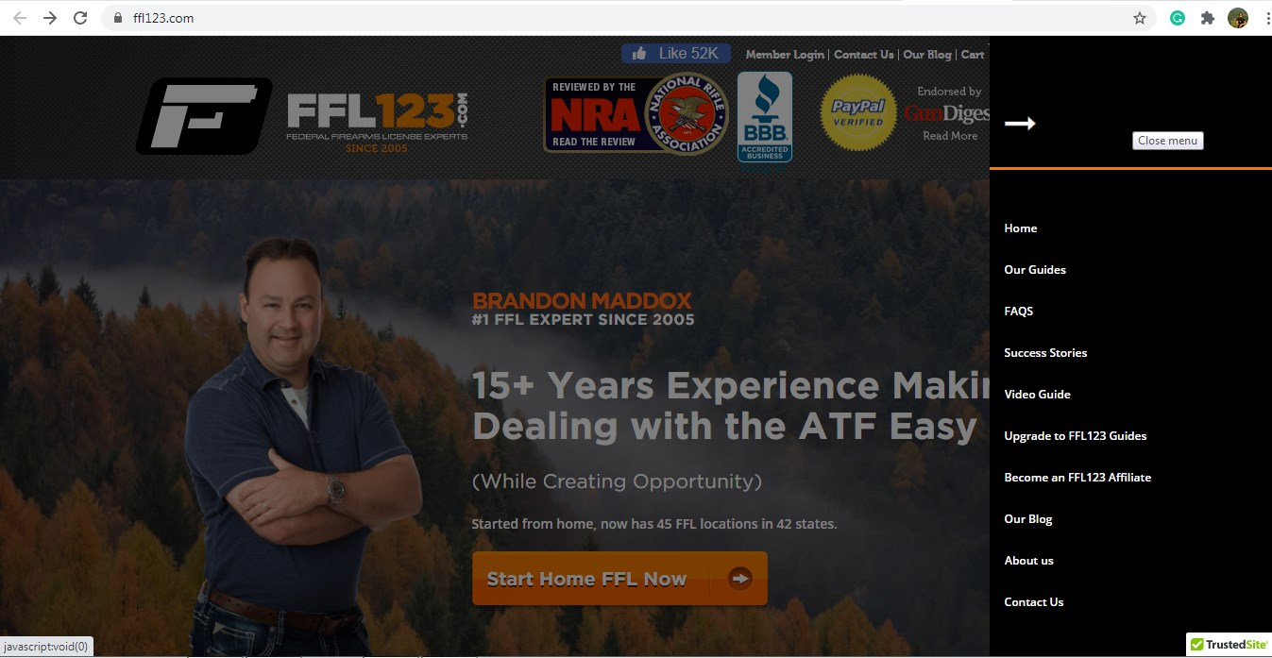

Suggestion: Make the elements bigger **Steps to reproduce:**

- Open the **https://www.ffl123.com/**

- On the top right, check the “Member login”, “Contact us”, “Our Blog”, “Cart” elements

- These elements should be made bigger, so that they are more visible

Screenshot:

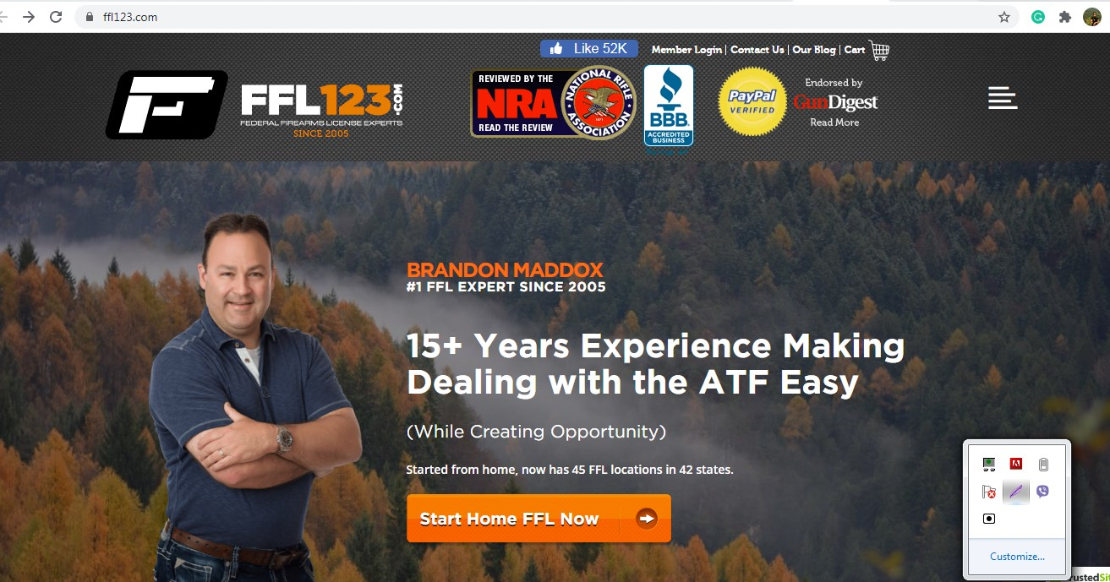

Suggestion: Highlight the main Logo **Steps to reproduce:**

- Open the **https://www.ffl123.com/**

- Check the logos on the top “FFL123”, “NRA”, “National Rifle Association”, “BBB” “Paypal”, “Gun Digest”’

- The user might be easily confused by these logos as it is not clear which one is the main logo

- The first logo, “FFL123” being the main logo of the website, should be highlighted and made bigger and more important than the rest of the logos.

Screenshot:



Suggestion: Highlight the main Logo **Steps to reproduce:**

- Open the **https://www.ffl123.com/**

- Check the “Start Home FFL now” button at the centre of the page

- The button leads to the Checkout, ordering a “Federal Firearms License Guide”

- It is not clear where the “Start Home FFL” button will lead the user

- It would be clearer if the button said “Get your copy of Federal Firearms License Guide”

Screenshot:



Suggestion: Make the “Act Now” clickable **Steps to reproduce:**

- Open the **https://www.ffl123.com/**

- Scroll down until you see “What are you waiting for? Act now!”  
- “Act now!” is in different color and the user might get the impression it’s clickable, but it’s not

- Make the “Act now!” clickable

Screenshot:

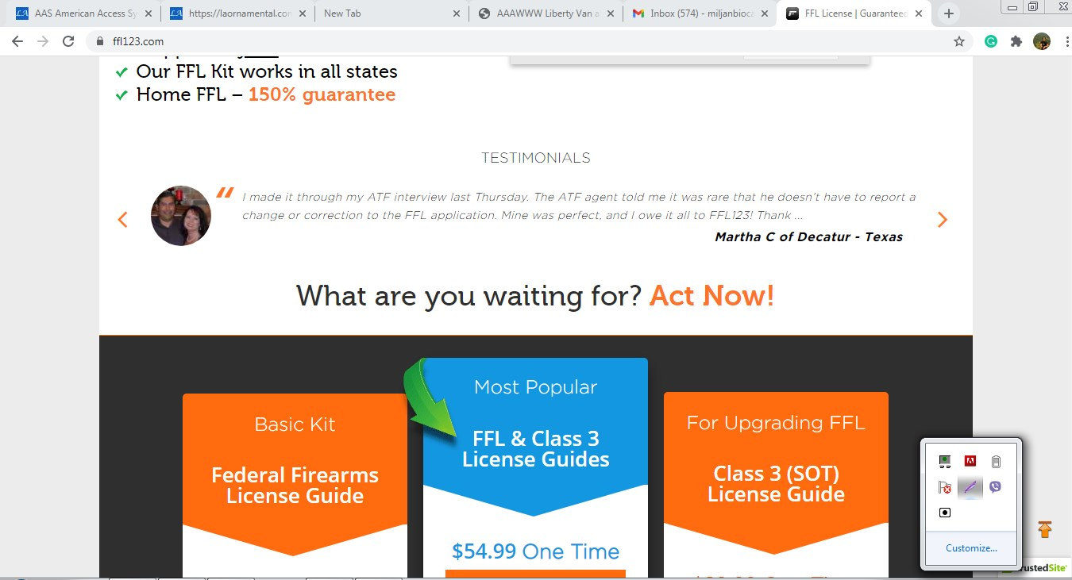

Suggestion: Change the layout of the main page  **Steps to reproduce:**

- Open the **https://www.ffl123.com/**

- Scroll down   
- Notice that the page is too long, seems chaotic, and it’s easy for user to lose a sense of what’s important

- Change the layout of the page to make it short, but effective, and highlight the main and important elements.

Screenshot:

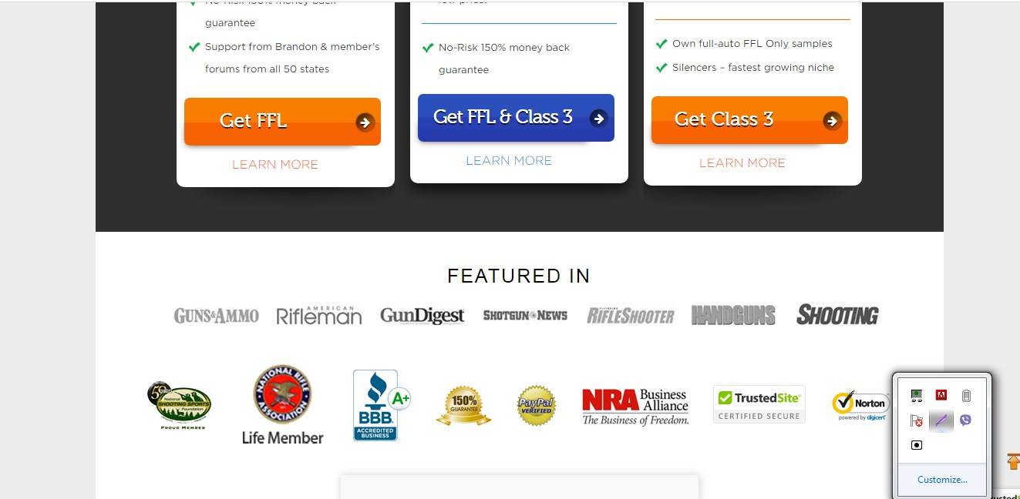

Suggestion: Remove the full Q&A section from the Home page  **Steps to reproduce:**

- Open the **https://www.ffl123.com/**

- Scroll down until you see “Q: What is an FFL 03?”

- Change the layout of the page to make it short, but effective, and highlight the main and important elements.

- Notice that Q&A section is displayed in full on the home page. However, user should be able to know where to find this section, even though the section doesn’t need to be displayed in full on the home page.  
  
Screenshot:

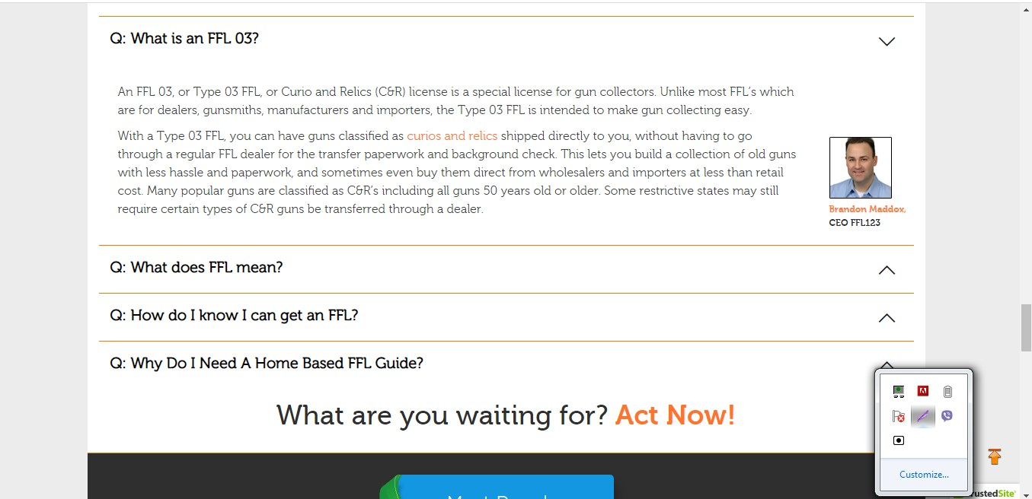

Suggestion: Remove the repeated elements from the Home Page  **Steps to reproduce:**

- Open the **https://www.ffl123.com/**

- Scroll all the way down

- Notice what scrolling that “What are you waiting for? Act now!” section and “Featured in” section are repeated twice

- Remove the copy of these sections, as it makes the home page over encumbered  
  
Screenshot:

